# assessments for Data Essentials

Answer all. Any queries let me know.

Due 28/8/2025

## Question 1 (25 marks)

Write a brief note on **any 5 of the following** (give examples/diagrams where appropriate):

1. Database relationships

**Database relationships** define how tables in a database are linked and how data from multiple tables can be integrated and retrieved. The relationships are established through primary keys and foreign keys.

1. The threats faced by a database administrator

**The threats faced by a database administrator** include many various threats that compromise the database in multiple ways, these threats can be Data Breaches, Data Loss/Corruption, Insider threats, etc.

1. Domains

**Domains** refer to the allowable values that a particular attribute in a database can have, e.g. an attribute called “Date” could be restricted to only accepting data in a DD/MM/YYYY format.

1. Layers of data abstraction
2. Data Protection Legislation
3. Referential Integrity

**Referential Integrity** is a concept in that ensures the consistency and validity of relationships between tables in a relational database. It ensures that foreign keys in one table always refer to valid, existing primary keys in another table.

1. Database keys

**Database keys** are crucial components for relational databases that maintain data integrity and establish relationships between tables, the main types of database keys are Primary Keys, Foreign Keys, Composite Keys, Candidate Keys.

## Question 2 (25 marks)

1. Using the bakery data Dataset spreadsheet, create charts that describe relationships the data.

Upload a Word document that contains the charts. In the Word document, you need to provide a brief description under each chart. Also, upload the excel spreadsheet.

Create one pivot table.

**Q.2.a Answer**

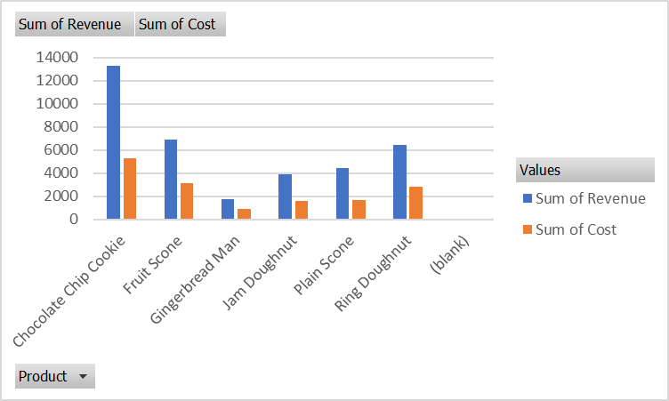

Figure 1 - Customer Revenue, Cost and Unit relationship for Product - OLE Linked Chart

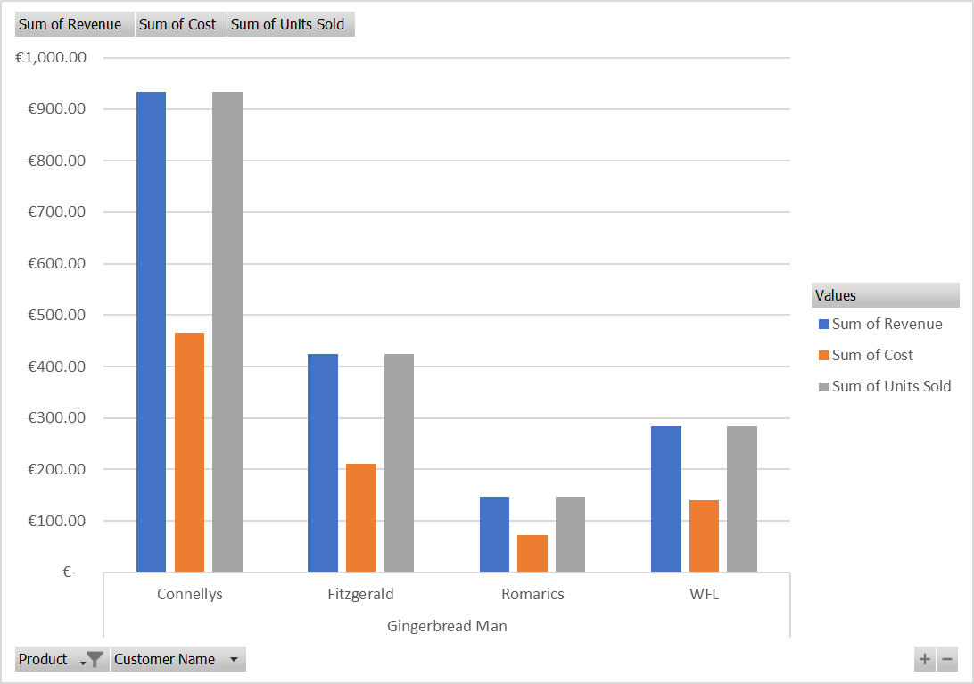

Figure 2 – Customer Revenue, Cost and Unit relationship for Gingerbread man Chart Screenshot



Figure 3 Pivot Table

## Question 3 (25 marks)

1. A table (relation) is subject to a number of rules/conditions. What are these?

**Q.3.a Answer**

1. Each table must have a unique name.
2. Each field must have a unique name.
3. Each table must have a primary key.
4. Each field must have a data type.
5. Tables are subject to Primary keys, Foreign keys and indexes/constraints.

**(10 marks)**

1. Given the following tables what are the field names, data types, primary keys/Foreign Key. Some to the data will be subject to the following properties: validation rules, default values or required. Indicate which data is subject to those properties and what might they be. Use blank template table below the data.

**(15 marks)**

|  |  |  |  |  |  |
| --- | --- | --- | --- | --- | --- |
| **Dog** table |  |  |  |  |  |
| **DogID** | **Name** | **DateOfBirth** | **Owner** | **Breed** | **OwnerContact** |
| 1 | Ben | 01/01/10 | Jim Brady | Poodle | 087-654654 |
| 2 | Spot | 01/01/07 | Paul Smith | Boxer | 086-111111 |
| 3 | Ruth | 06/11/09 | Mary Jones | Terrier | 085-154545 |

|  |  |  |  |  |  |  |  |  |  |  |  |  |  |  |
| --- | --- | --- | --- | --- | --- | --- | --- | --- | --- | --- | --- | --- | --- | --- |
| **DogGrooming** | | table | |  |  | | |  |  | |  | |  | |
| **Grooming** | **DogID** | | **Date** | | | **Time** | **Where** | | | **Fee** | | **Paid** | | **Groomer** | |
| Shampoo | 1 | | 01/05/14 | | | 11:00 | Office | | | €25 | | Yes | | Marie | |
| Hair trim | 2 | | 01/05/14 | | | 12:00 | Home | | | €35 | | No | | Glen | |
| Deshedding | 1 | | 02/05/14 | | | 10:00 | Office | | | €45 | | Yes | | Marie | |

# Meta-Data

Document **ALL** your **entity/attributes** from the above two tables with the following format:

Entity/Attribute (Table/field)

**Q.3.b Answer**

|  |  |  |  |  |  |
| --- | --- | --- | --- | --- | --- |
| **EntityName** | **AttributeName** | **Data Type** | **Size** | **Null/Not Null** | **Constraint** |
| Dog | DogID | INT | 11 | Not Null | Primary Key |
| Dog | Name | VARCHAR | 50 | Not Null | Composite Key 1 |
| Dog | DateOfBirth | DATE |  | Not Null | Composite Key 1 |
| Dog | Owner | VARCHAR | 50 | Not Null | Composite Key 1 |
| Dog | Breed | VARCHAR | 50 | Not Null |  |
| Dog | OwnerContact | VARCHAR | 50 | Not Null |  |

| **EntityName** | **AttributeName** | **Data Type** | **Size** | **Null/Not Null** | **Constraint** |
| --- | --- | --- | --- | --- | --- |
| DogGrooming | Grooming | VARCHAR | 50 | Not Null |  |
| DogGrooming | DogID | INT | 11 | Not Null | Foreign Key |
| DogGrooming | Date | DATE |  | Not Null | Primary Key 1 |
| DogGrooming | Time | TIME |  | Not Null | Primary Key 1 |
| DogGrooming | Where | VARCHAR | 50 | Not Null | Primary Key 1 |
| DogGrooming | Fee | DECIMAL | 10,2 | Not Null |  |
| DogGrooming | Paid | ENUM | 1 | Not Null |  |
| DogGrooming | Groomer | VARCHAR | 50 | Not Null | Primary Key 1 |

**Question 4 (Total 25 marks)**

For the description below, you are to:

i) Create a Conceptual Model for the passage below.

ii) Create the Logical/Physical E-R diagram, including some attributes (primary keys / foreign keys) and cardinality/modality

iii) Prepare a text description explaining your E-R diagram assumptions (max 5 best 3 marked)

iv) Write up in English 3 queries (questions) with justification: One involving only one table and the others involving two or more tables

v) What’s missing in terms of other table(s) and fields (attributes).

Hint: Think very carefully about what needs to be recorded. Note that some of the elements in this description may be ‘red herrings’ (i.e. not relevant). Note any decisions you make in your text description of your E-R model. You may assume any further information as is reasonable to complete the assignment. Any such assumptions should be recorded and submitted with your assignment. State any assumptions that you need to make about optional/mandatory relationships.

Moylish Medical Centre is a fast-growing medical practice based on the north side of Limerick city. It provides medical services for a large number of private clients (patients) and for a number of General Practitioners (G.P.s) in the city.

The procedure would be for private clients to come in as per a normal GP practice, for medical check-ups and advise. The client typically rings up the center and makes an appointment to meet one of our six full-time GP’s with the centres two secretaries. The GP assesses the client in the center and will administer the appropriate course of medical care/treatment.

Sometimes a GP has to make a house call. Again details of this visit need to be recorded.

The medical center recently began to offer a small number of medical tests in its newly built biochemistry and hematology laboratory. Demand has been such that they now are offering a large number of biochemistry tests and a small number of core hematology tests. Screening tests for the centers patients are carried out at this laboratory as well as for a number of other GP practices in the area. The samples have to be labeled appropriately by an administration person in the center and are then passed on to the two biochemists who prepare and analyse the specimens and present the findings to the GP’s (if abnormal) or to the administration person to enter in the patients file (if normal).

Each GP is assigned their own room. The Centre employs contract cleaning services to keep the place hygienically clean. They do their work when the centre is closed.

Storing of the medical goods is another problem. A store manager who tries to keep the current stocks within its best before date runs the store. He also tries to minimise the stock held at any given time while ensuring that there is sufficient stock on hand to meet the centres requirements. Details of suppliers of these stock items are also held along with orders that are placed.

Every so often the staff attend conferences/training days. This needs to be recorded. Details of the conference/training day need to be stored, along with who attended. Some of the recorded details of these trips include departure date, return date, and times. Also, a record needs to be kept of any expenses incurred by staff on these trips (the expense name, amount and date).

**Q.4.i Answer**

Note: A Staff member sharing name/surname with the GP Tables and Store Manager Table doesn't justify linking systems.

*Note: The database for the cleaning service should be completely independent of the medical center's database. Both databases having a room table does not justify linking the systems given the sensitivity of the medical records*

Figure 4

Figure 5

Figure 6

Figure 7

**Q.4.ii Answer**

Figure 8

Figure 9

Figure 10

Figure 11

**Q.4.iii Answer**

### E-R Diagram Assumptions

#### Client and GP Relationships:

**Assumption**:  
Each client can see multiple GPs, and each GP can see multiple clients.

**Explanation**:  
This many-to-many relationship is represented by the Client and GP entities with a linking table or direct relationship indicating that clients can have multiple GPs and vice versa.

#### House Calls:

**Assumption**:  
House calls are specific visits made by GPs to clients' homes.

**Explanation**:  
The HouseCall entity includes foreign keys to both Client and GP, indicating which GP made the house call to which client. This entity also includes details such as the visit date and address.

#### Lab Tests:

**Assumption**:  
Lab tests are categorized into biochemistry and hematology, and each test is associated with a specific client and ordered by a specific GP.

**Explanation**:  
The BiochemistryLabTest and HematologyLabTest entities include foreign keys to both Client and GP, indicating which client the test is for and which GP ordered it. Each test entity also includes details such as test date, name, result, and status.

#### Store Management:

**Assumption**:  
Store managers are responsible for managing stock items, and each stock item is managed by one store manager.

**Explanation**:  
The StoreManager entity is linked to the StockItem entity, indicating that each stock item is managed by a specific store manager. This relationship helps in tracking responsibility and inventory management.

#### Medical Items and Orders:

**Assumption**:  
Medical items are part of stock items and can be ordered from suppliers.

**Explanation**:  
The MedicalItem entity is linked to the StockItem entity, indicating that medical items are part of the stock. The Order entity includes foreign keys to both Supplier and MedicalItem, indicating which supplier the order is from and which medical items are included in the order.

**Q.4.iv Answer**

1. **Query 1 (One Table)**: Retrieve the names of all clients who have visited the medical center.  
   *Justification*: This query involves a single table (Client) and aims to retrieve specific information (names) from that table. It does not require any joins with other tables as the information is self-contained within the Client table. To avoid redundancy, the query could include a DISTINCT keyword to ensure unique client names are returned.
2. **Query 2 (Two Tables)**: Retrieve the names of clients along with the names of their GPs.  
   *Justification*: This query involves two tables (Client and GP) and aims to retrieve information that is related across these tables. A join operation is required to link clients with their respective GPs. This query helps in understanding the relationship between clients and GPs and provides a comprehensive view of which GP is associated with which client.
3. **Query 3 (Three Tables)**: Retrieve the details of house calls, including the client's name, GP's name, and the date of the visit.  
   *Justification*: This query involves three tables (Client, GP, and HouseCall) and aims to retrieve detailed information about house calls. A join operation is required to link the house call details with the respective clients and GPs. This query provides a complete view of house call activities, including who visited whom and when, which is essential for tracking and managing house call services.

**Q.4.v Answer**

The description provided lacks details on the relationships between entities and the attributes associated with those relationships. For example, the passage mentions that GPs make house calls, but it does not specify how these house calls are related to clients or other entities in the system. Additionally, the description does not include information on the specific tests conducted in the biochemistry and hematology labs, which would require additional entities and attributes to capture the test names, results, and other relevant details. Furthermore, details on the suppliers of medical goods, orders placed, and stock management are mentioned but not fully elaborated, indicating a need for additional entities and attributes to model these aspects of the medical center's operations.